Supporting Information
Testing the wind disruption and disturbance refugia hypothesis for mountain pine beetle outbreaks (Dendroctonus ponderosae). Terrain, stand density and flight-period wind as controls on attack in the Selkirk Mountains of British Columbia
Seamus Murphy

Table S1
The datasets the study combined, with the spatial and temporal resolution of each.
Dataset | Source | Spatial | Temporal | Extent
Red-stage attack | Landsat 5 and 8 Collection 2 Level-2 | 30 m | 16 days | 47 periods
Stand structure | Vegetation Resources Inventory, annual releases | 30 m, rasterised | 1 year | 8 snapshots
Terrain | Natural Resources Canada High Resolution Digital Elevation Model | 30 m | static | 61,923 cells
Station wind | Environment and Climate Change Canada hourly stations | 9 stations within 150 km | 1 hour | 19,157 hours
Terrain-resolved wind | MicroMet terrain adjustment of station wind | 30 m | 16 days | 47 periods
Model table | Rows joined from the above | 30 m | 16 days | 173,086 cell-periods

Table S2
Every sixteen-day period used, with the cells the imagery saw, the share classed as attacked, and the point pattern statistics of the attacked cells. NN ratio was the mean nearest-neighbour distance of the attacked cells over its mean under 999 random relabellings of the cells seen, Range the largest distance at which the L function lay above its global envelope, and Bandwidth the likelihood cross-validated kernel bandwidth.
Year | Period | Start | Cells seen | Attacked (%) | Clark-Evans R | NN ratio | Range (m) | Bandwidth (m)
2006 | 1 | 2006-05-01 | 48,329 | 5.6 | 0.648 | 0.597 | 1200 | 70
2006 | 2 | 2006-05-17 | 16,703 | 8.4 | 0.808 | 0.689 | 300 | 90
2006 | 3 | 2006-06-02 | 9,426 | 26.0 | 1.170 | 0.909 | 510 | 99
2006 | 4 | 2006-06-18 | 18,568 | 11.2 | 0.846 | 0.720 | 210 | 67
2006 | 5 | 2006-07-04 | 55,107 | 17.3 | 0.954 | 0.827 | 1320 | 58
2006 | 6 | 2006-07-20 | 41,218 | 9.4 | 0.866 | 0.785 | 660 | 70
2006 | 7 | 2006-08-05 | 46,263 | 5.7 | 0.743 | 0.685 | 1230 | 85
2006 | 8 | 2006-08-21 | 60,102 | 12.4 | 0.975 | 0.881 | 1470 | 74
2007 | 1 | 2007-05-01 | 50,919 | 9.9 | 0.784 | 0.706 | 900 | 74
2007 | 5 | 2007-07-04 | 56,511 | 13.3 | 0.894 | 0.800 | 750 | 64
2007 | 6 | 2007-07-20 | 41,218 | 18.3 | 1.032 | 0.886 | 360 | 64
2007 | 7 | 2007-08-05 | 61,246 | 11.3 | 0.903 | 0.822 | 1050 | 70
2007 | 8 | 2007-08-21 | 35,655 | 12.6 | 0.936 | 0.831 | 480 | 70
2008 | 3 | 2008-06-02 | 9,932 | 57.4 | 1.563 | 0.993 | 510 | 90
2008 | 5 | 2008-07-04 | 15,069 | 9.8 | 0.865 | 0.767 | 240 | 104
2008 | 6 | 2008-07-20 | 6,293 | 7.8 | 0.652 | 0.534 | 210 | 53
2008 | 7 | 2008-08-05 | 53,059 | 8.6 | 0.769 | 0.704 | 1020 | 81
2008 | 8 | 2008-08-21 | 9,279 | 9.5 | 0.834 | 0.727 | 90 | 145
2009 | 1 | 2009-05-01 | 17,062 | 10.9 | 0.764 | 0.672 | 750 | 64
2009 | 2 | 2009-05-17 | 37,124 | 15.2 | 0.884 | 0.773 | 1020 | 55
2009 | 4 | 2009-06-18 | 18,566 | 12.3 | 0.874 | 0.741 | 120 | 64
2009 | 5 | 2009-07-04 | 56,511 | 16.2 | 0.952 | 0.835 | 1410 | 64
2009 | 6 | 2009-07-20 | 35,156 | 10.5 | 0.795 | 0.715 | 720 | 85
2009 | 7 | 2009-08-05 | 61,246 | 11.0 | 0.879 | 0.801 | 1260 | 74
2009 | 8 | 2009-08-21 | 35,147 | 39.0 | 1.311 | 0.968 | 1380 | 64
2010 | 1 | 2010-05-01 | 13,007 | 10.2 | 0.744 | 0.641 | 270 | 94
2010 | 4 | 2010-06-18 | 9,106 | 37.4 | 1.329 | 0.953 | 0 | 90
2010 | 5 | 2010-07-04 | 17,158 | 23.1 | 1.035 | 0.837 | 600 | 64
2010 | 7 | 2010-08-05 | 59,387 | 11.5 | 0.816 | 0.740 | 930 | 67
2010 | 8 | 2010-08-21 | 8,618 | 26.3 | 1.130 | 0.864 | 270 | 90
2011 | 2 | 2011-05-17 | 14,102 | 5.7 | 0.554 | 0.488 | 270 | 58
2011 | 4 | 2011-06-18 | 8,606 | 18.9 | 1.021 | 0.817 | 0 | 99
2011 | 5 | 2011-07-04 | 53,179 | 23.7 | 1.064 | 0.884 | 1380 | 67
2011 | 6 | 2011-07-20 | 32,384 | 15.4 | 0.907 | 0.782 | 510 | 64
2011 | 7 | 2011-08-05 | 61,246 | 13.8 | 0.912 | 0.817 | 1500 | 70
2011 | 8 | 2011-08-21 | 60,102 | 17.8 | 1.003 | 0.873 | 1500 | 70
2013 | 1 | 2013-05-01 | 29,392 | 8.5 | 0.734 | 0.641 | 360 | 70
2013 | 4 | 2013-06-18 | 12,760 | 33.1 | 1.211 | 0.907 | 750 | 64
2013 | 5 | 2013-07-04 | 45,303 | 22.6 | 1.046 | 0.874 | 1320 | 64
2013 | 6 | 2013-07-20 | 39,873 | 25.8 | 1.108 | 0.903 | 630 | 61
2013 | 7 | 2013-08-05 | 43,605 | 38.8 | 1.299 | 0.968 | 1020 | 67
2013 | 8 | 2013-08-21 | 59,452 | 34.2 | 1.244 | 0.962 | 1440 | 64
2014 | 1 | 2014-05-01 | 53,035 | 11.1 | 0.771 | 0.694 | 1260 | 61
2014 | 2 | 2014-05-17 | 9,048 | 7.4 | 0.718 | 0.624 | 330 | 81
2014 | 4 | 2014-06-18 | 18,286 | 29.2 | 1.154 | 0.895 | 630 | 58
2014 | 5 | 2014-07-04 | 44,890 | 20.2 | 0.990 | 0.842 | 570 | 58
2014 | 7 | 2014-08-05 | 56,249 | 22.9 | 1.048 | 0.879 | 1500 | 61

Methods S1
The wind component of the MicroMet model of Liston & Elder (2006) is seven equations, implemented directly from the source paper with its equation numbers given below.
Terrain slope $β$ and slope azimuth $ξ$ came from the elevation model, equations 12 and 13 of Liston & Elder (2006). Curvature $Ω_{c}$ is a cell’s elevation minus the mean of the two opposite cells one curvature length scale away, taken on four direction lines and averaged, their equation 14, and the length scale was estimated as the first lag at which elevation autocorrelation fell below 0.5, which was 600 m here. Assigning $θ$ to wind bearing, slope in the wind direction was computed as follows
$$Ω_{s}=βcos\left(θ−ξ\right) \left(1\right)$$
with $Ω_{s}$ and $Ω_{c}$ each scaled to $\left[−0.5, 0.5\right]$. The terrain weighting factor applied to the observed speed $W$ was derived using
$$W_{w}=1+γ_{s}Ω_{s}+γ_{c}Ω_{c}, γ_{s}=γ_{c}=0.5 \left(2\right)$$
This provided the basis for calculation of the terrain-modified speed using
$$W_{t}=W_{w}W \left(3\right)$$
and a diversion of wind direction computed as
$$θ_{d}=−1/2 Ω_{s}sin​\left[2\left(ξ−θ\right)\right]. \left(4\right)$$
By Equation 2, $W_{w}$ depends on direction and not on speed, so it was computed once for each of 16 wind direction sectors of 22.5 degrees, the sixteen points of the compass, and each hourly observation was multiplied by the surface for its own sector, so that nothing was averaged before the terrain acted on it, and over all sectors $W_{w}$ ran from 0.66 to 1.32.

Table S3
Each environmental variable entered alone beside the dependence terms and tested against the dependence-only model by likelihood ratio, ordered by the test statistic. Estimates were changes in log-odds per standard deviation, and the within-period SD share was the mean standard deviation within a period over the standard deviation across all periods. Significance of the likelihood-ratio test was marked * p ≤ 0.05, ** p ≤ 0.01, *** p ≤ 0.001, **** p ≤ 0.0001.
Variable | LR chi-square | Estimate | SE | Within-period SD share
Height above valley floor (m) | 255.49 | -0.211**** | 0.013 | 0.95
Elevation (m) | 250.29 | +0.221**** | 0.014 | 0.89
Effective air flow height | 249.79 | +0.221**** | 0.014 | 0.89
Valley depth (m) | 230.29 | -0.206**** | 0.014 | 0.93
Sky view factor | 205.04 | +0.196**** | 0.014 | 0.95
Crown closure (%) | 180.05 | +0.173**** | 0.013 | 0.97
Stand basal area (m² ha⁻¹) | 160.68 | +0.164**** | 0.013 | 0.96
Susceptible pine basal area (m² ha⁻¹) | 145.68 | +0.176**** | 0.015 | 0.94
Positive openness | 144.36 | +0.156**** | 0.013 | 0.97
Normalised height | 126.59 | +0.145**** | 0.013 | 0.98
Slope (degrees) | 106.16 | -0.138**** | 0.013 | 0.94
Terrain ruggedness index | 104.70 | -0.137**** | 0.013 | 0.95
Stand age (years) | 89.04 | +0.119**** | 0.013 | 0.97
Lodgepole pine cover (%) | 78.99 | +0.122**** | 0.014 | 0.96
Standing volume (m³ ha⁻¹) | 78.78 | +0.116**** | 0.013 | 0.92
Live stems (n/ha) | 72.32 | +0.109**** | 0.013 | 0.98
Topographic position index | 64.38 | +0.100**** | 0.012 | 1.01
Vector ruggedness measure | 61.43 | -0.101**** | 0.013 | 0.96
Northness | 49.79 | +0.094**** | 0.013 | 0.88
Wind exposition index | 43.61 | +0.083**** | 0.013 | 0.99
Multi-scale topographic position | 25.14 | +0.062**** | 0.012 | 1.01
Windward-leeward index | 22.96 | +0.063**** | 0.013 | 0.91
Flight-window diffuse radiation (kWh/m²) | 17.53 | -0.054**** | 0.013 | 0.93
Flight-hour calm share | 16.41 | -0.214**** | 0.053 | 0.24
Heat load index | 13.64 | -0.049*** | 0.013 | 0.90
Stand height (m) | 12.99 | +0.046*** | 0.013 | 0.95
Topographic wetness index | 11.79 | -0.043*** | 0.013 | 0.94
Plan curvature | 9.81 | +0.040** | 0.013 | 0.96
Convergence index | 7.90 | +0.036** | 0.013 | 0.99
Wind shelter index | 7.23 | -0.034** | 0.013 | 0.95
Quadratic mean diameter (cm) | 5.49 | +0.030* | 0.013 | 1.03
Growing-season total radiation (kWh/m²) | 4.57 | -0.028* | 0.013 | 0.89
Growing-season direct radiation (kWh/m²) | 4.11 | -0.027* | 0.013 | 0.89
Profile curvature | 3.57 | +0.024 | 0.012 | 1.03
Eastness | 3.03 | -0.023 | 0.013 | 0.93
Mid-slope position | 2.73 | +0.021 | 0.013 | 0.99
Negative openness | 1.30 | -0.014 | 0.013 | 0.97
Flight-window direct radiation (kWh/m²) | 0.59 | +0.010 | 0.013 | 0.92
Flight-hour wind (km/h) | 0.05 | +0.007 | 0.030 | 0.38

Table S4
The candidates that passed the likelihood-ratio screen and the collinearity rule, with whether the elastic net kept each at the penalty of minimum cross-validated deviance and at one standard error above it, and whether backward elimination by AIC kept it in the final model.
Candidate | Elastic net, lambda min | Elastic net, lambda 1SE | Final model
Height above valley floor (m) | kept | kept | kept
Elevation (m) | kept | kept | kept
Valley depth (m) | kept | kept
Crown closure (%) | kept | kept | kept
Susceptible pine basal area (m² ha⁻¹) | kept |  | kept
Normalised height | kept |  | kept
Stand age (years) | kept |  | kept
Live stems (n/ha) | kept
Topographic position index
Vector ruggedness measure | kept |  | kept
Northness | kept |  | kept
Multi-scale topographic position
Windward-leeward index
Flight-window diffuse radiation (kWh/m²) | kept
Flight-hour calm share
Stand height (m) | kept |  | kept
Topographic wetness index | kept |  | kept
Plan curvature | kept |  | kept

Figure S1
The flight window against the landscape’s own climate, from hourly Environment and Climate Change Canada station records for May to September of the study years. The shaded band marked the window, 1 July to 15 August, taken from the bionomics and not fitted to these data. (a) Mean afternoon temperature by day of year, with the 19 to 41 degrees C flight range and the 22 to 32 degrees C peak band marked. (b) The share of afternoon hours inside the flight range, day by day. (c) Mean temperature and the share of all hours inside the flight range, by hour, with the 12:00 to 17:00 restriction shaded. (d) Mean wind speed by hour on the same axis, showing that the hours in which the beetle could fly were also the windiest of the day.
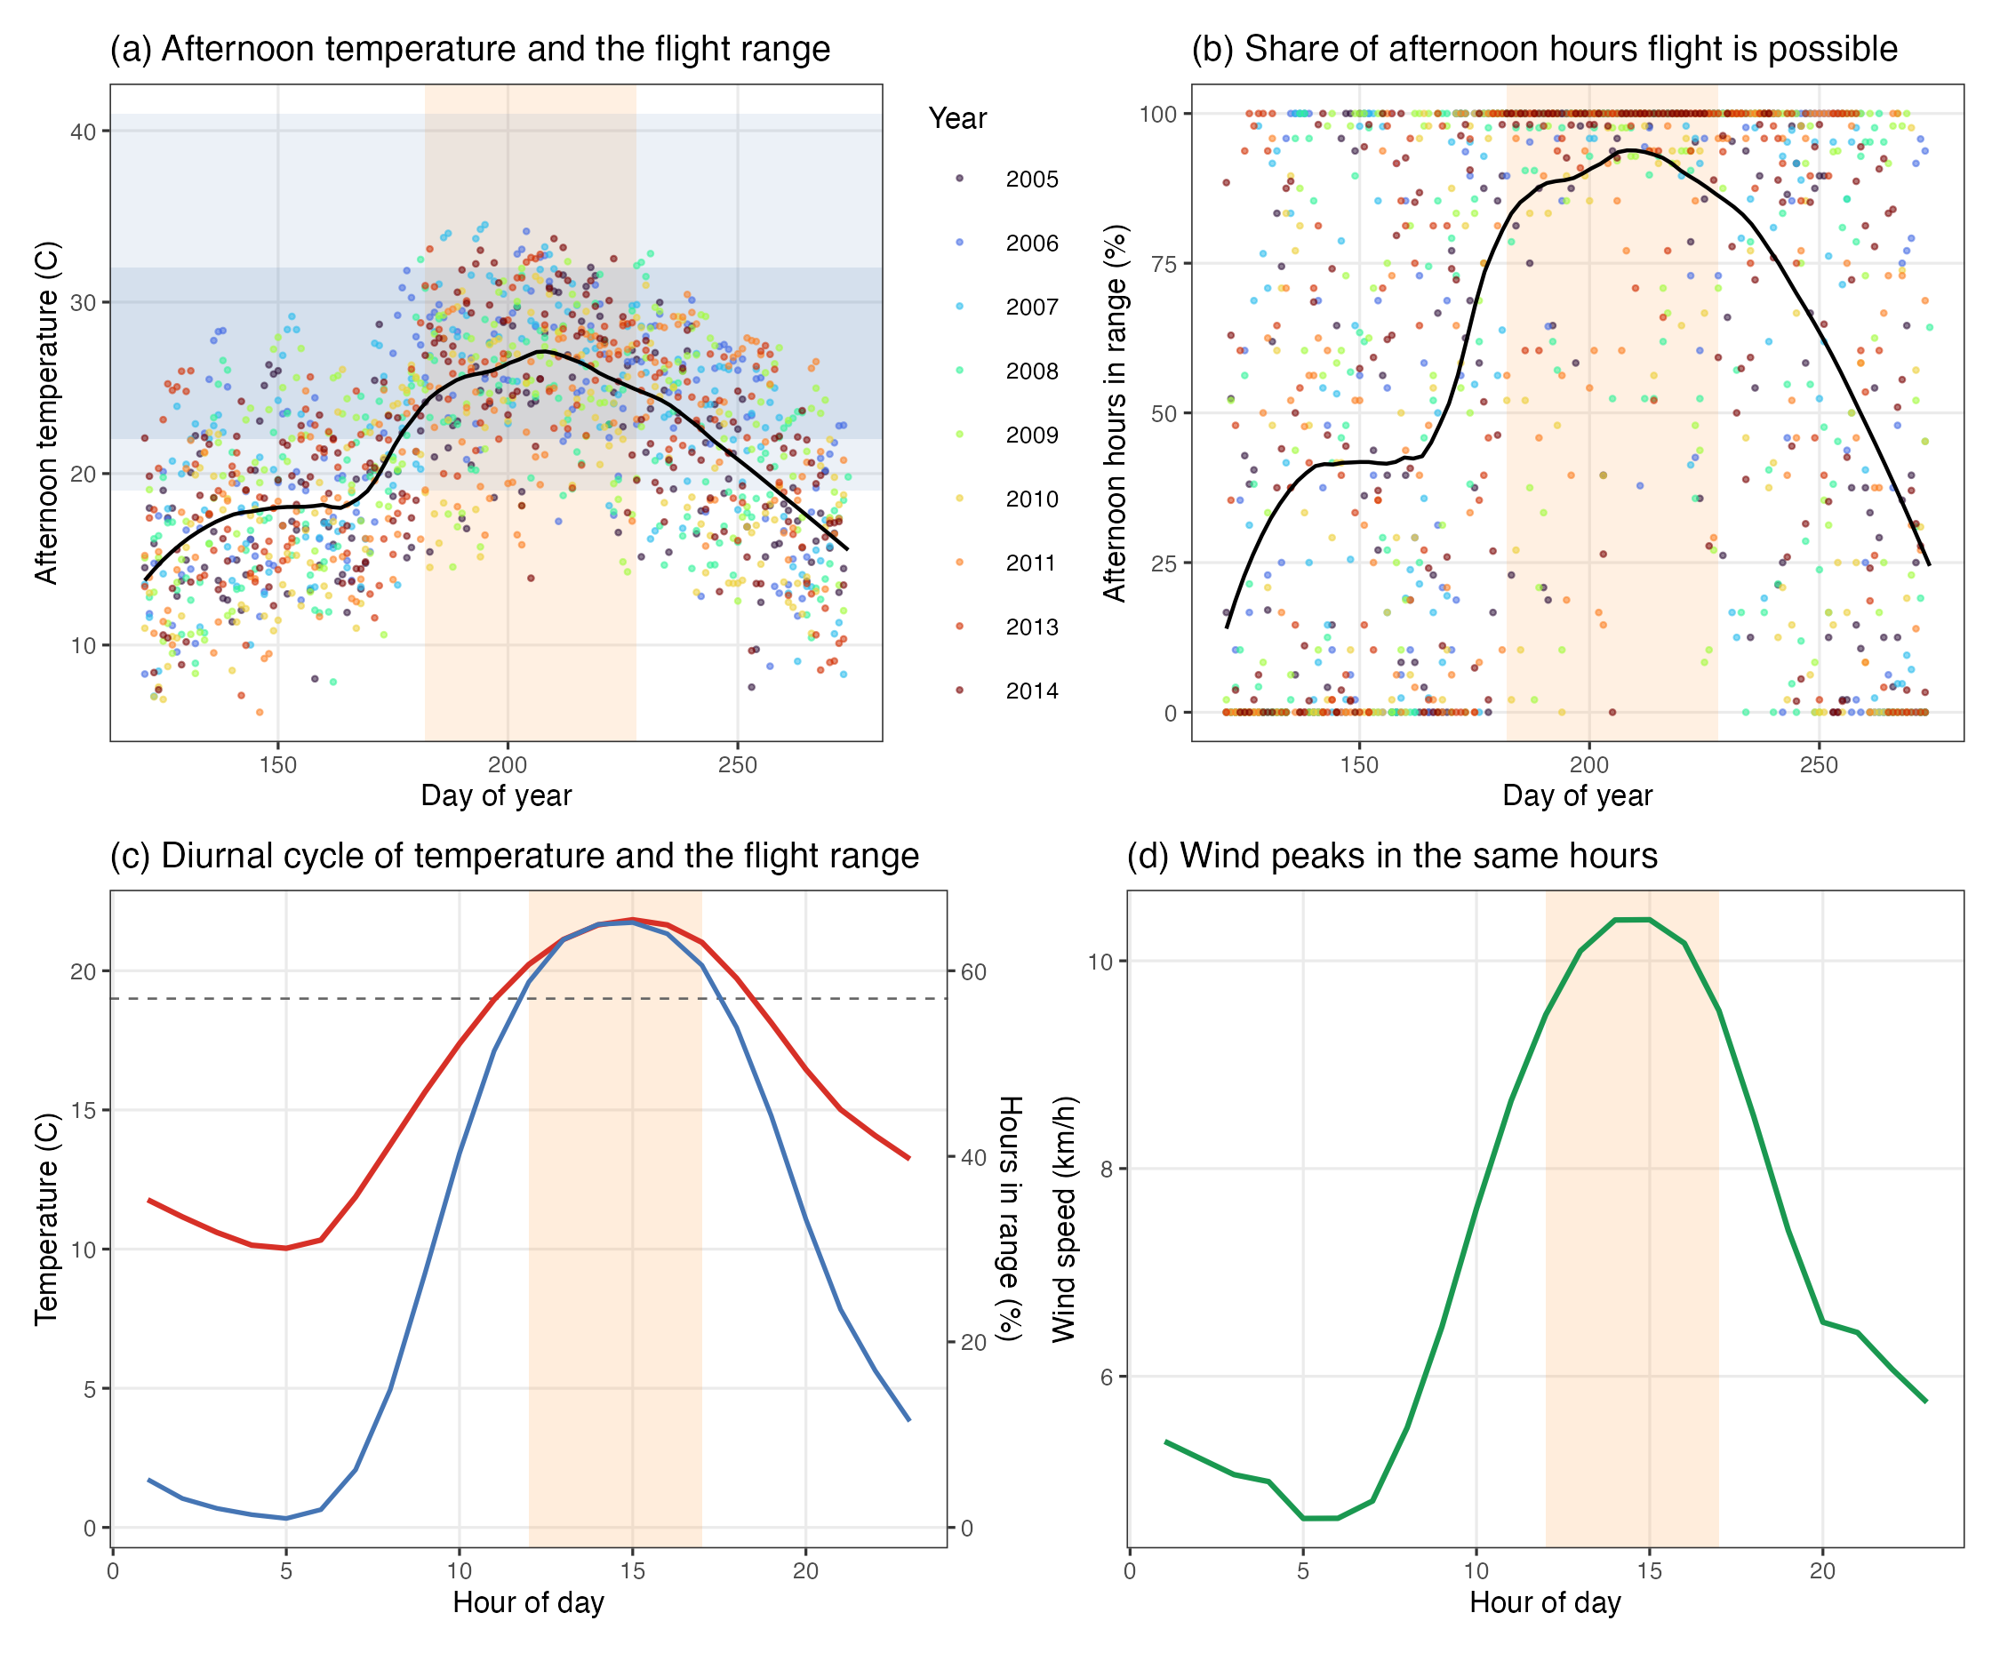

References
Liston, G. E., & Elder, K. (2006). A meteorological distribution system for high-resolution terrestrial modeling (MicroMet). Journal of Hydrometeorology, 7(2), 217–234. https://doi.org/10.1175/JHM486.1

